**Lab Execution:-**

**Assignment No. 1:-** Predict the price of the Uber ride from a given pickup point to the agreed drop-off location.Perform following tasks:1. Pre-process the dataset.2. Identify outliers.3. Check the correlation.4. Implement linear regression and random forest regression models.5. Evaluate the models and compare their respective scores like R2, RMSE, etc.Dataset link:<https://www.kaggle.com/datasets/yasserh/uber-fares-dataset>

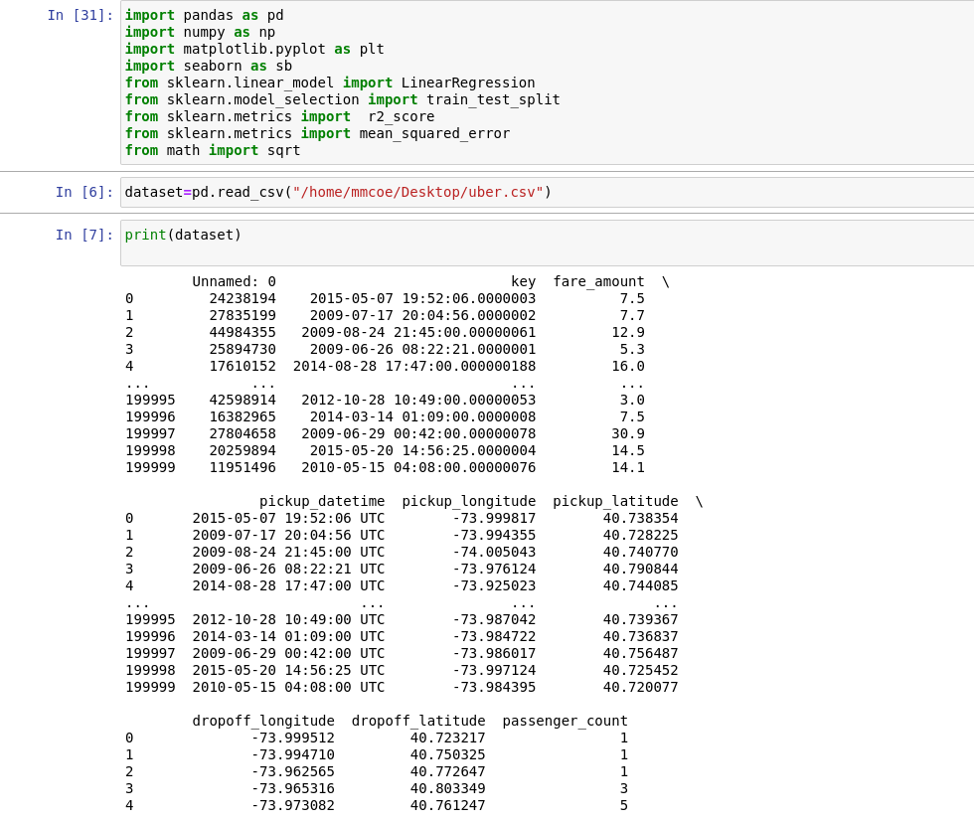

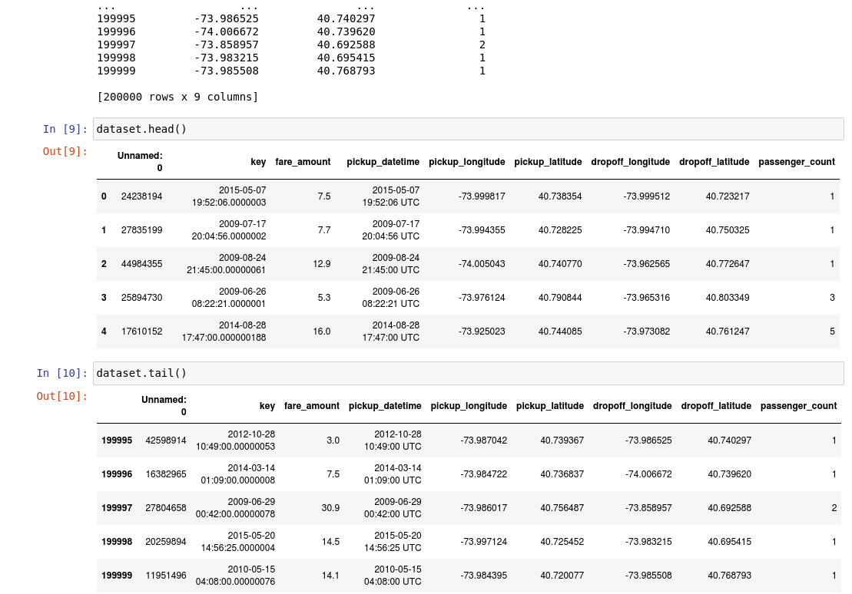

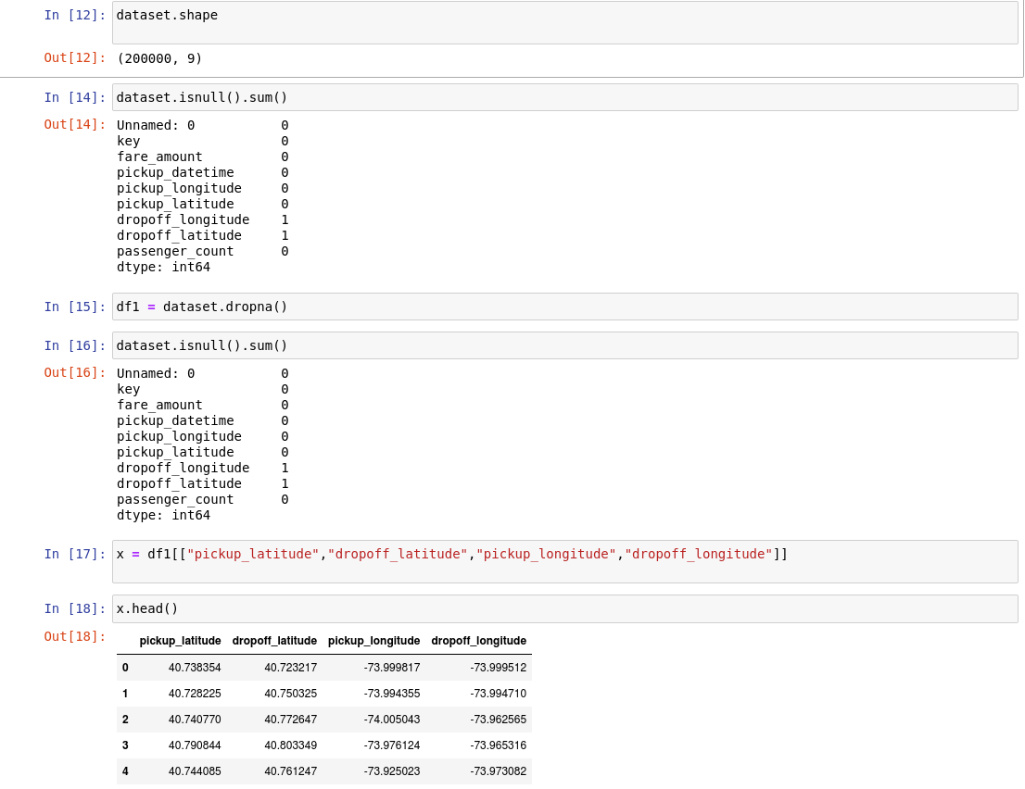

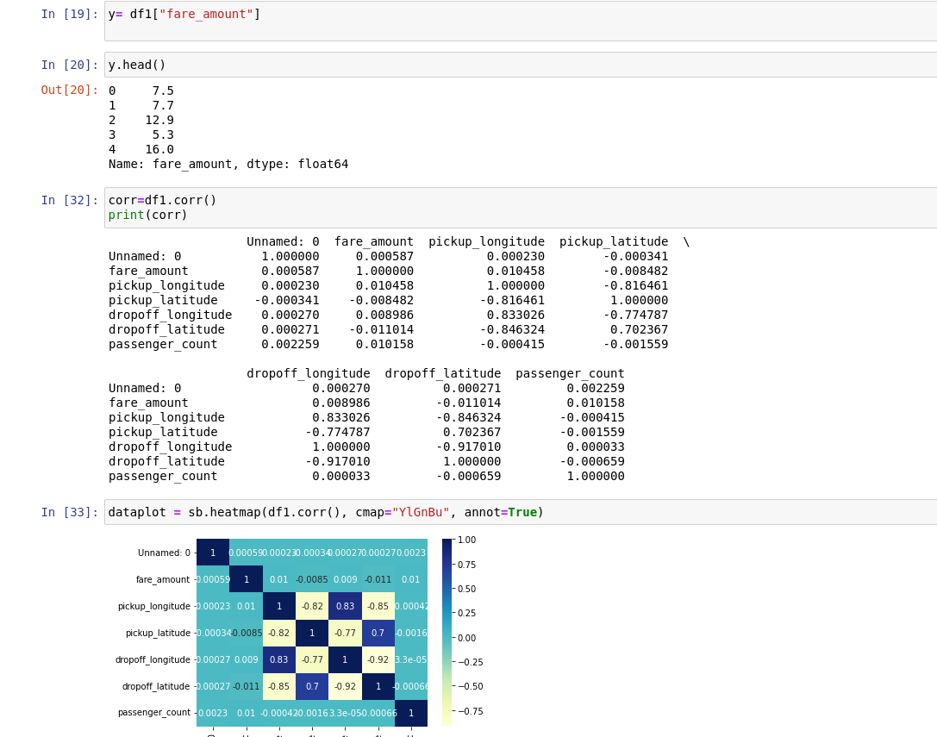

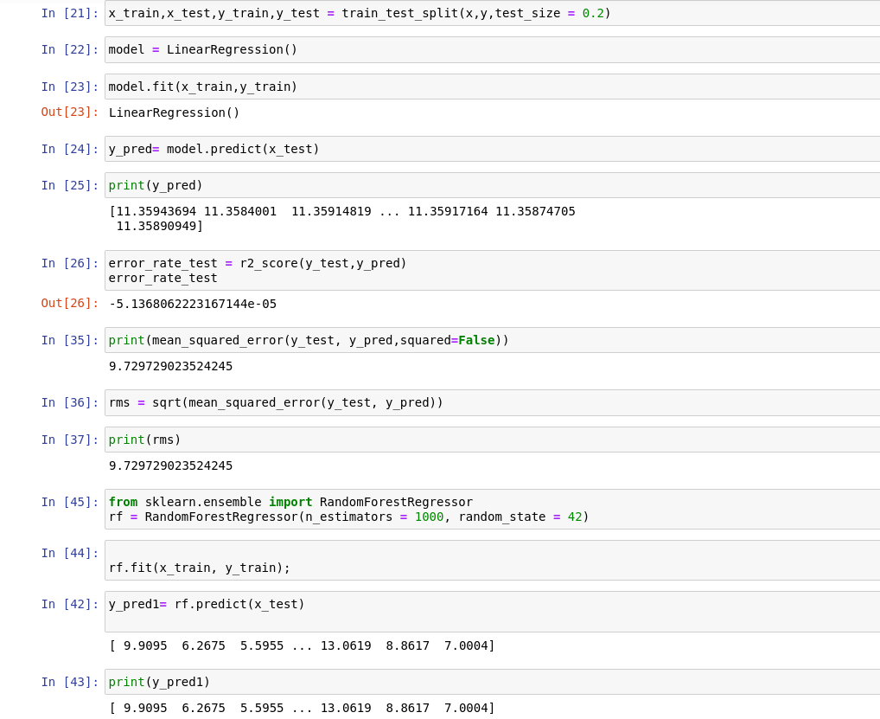

**Assignment No. 2:-** Classify the email using the binary classification method. Email Spam detection has two states: a) Normal State –Not Spam, b) Abnormal State –Spam. Use K-Nearest Neighbors and Support Vector Machine for classification. Analyze their performance.Dataset link: The emails.csv dataset on the Kaggle <https://www.kaggle.com/datasets/balaka18/email-spam-classification-dataset-csv>.

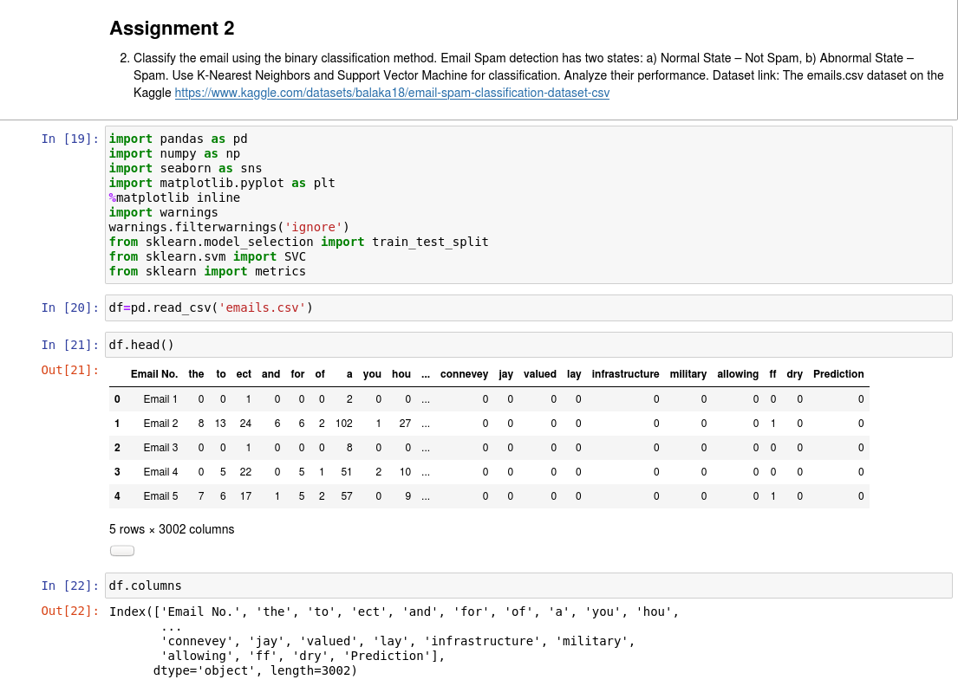

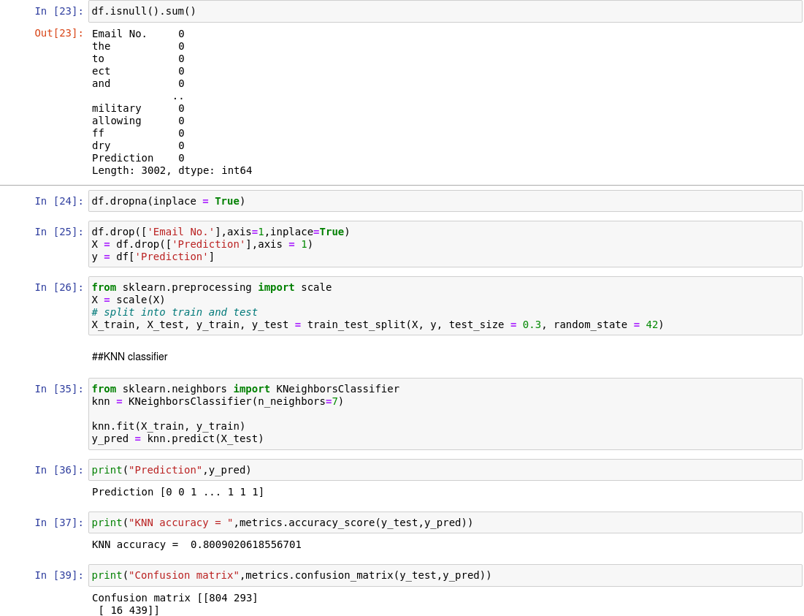

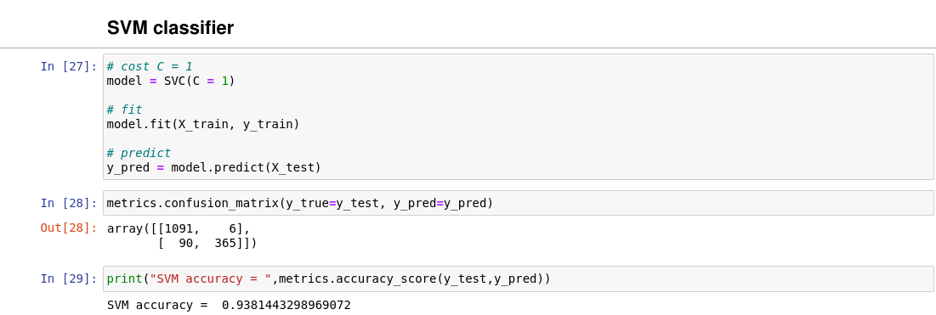

**Assignment No. 3:-** Implement Gradient Descent Algorithm to find the local minima of a function.

For example, find the local minima of the function y=(x+3)2 starting from the point x=2.

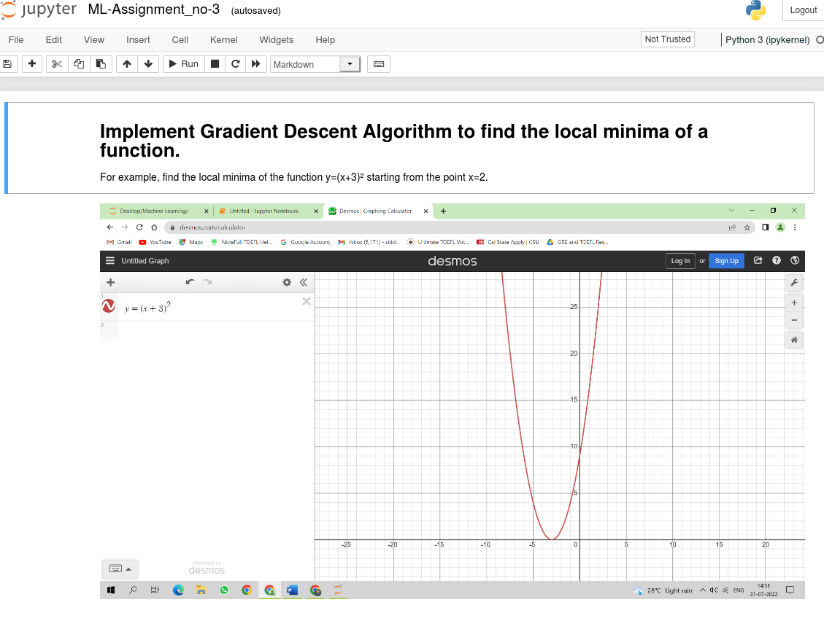

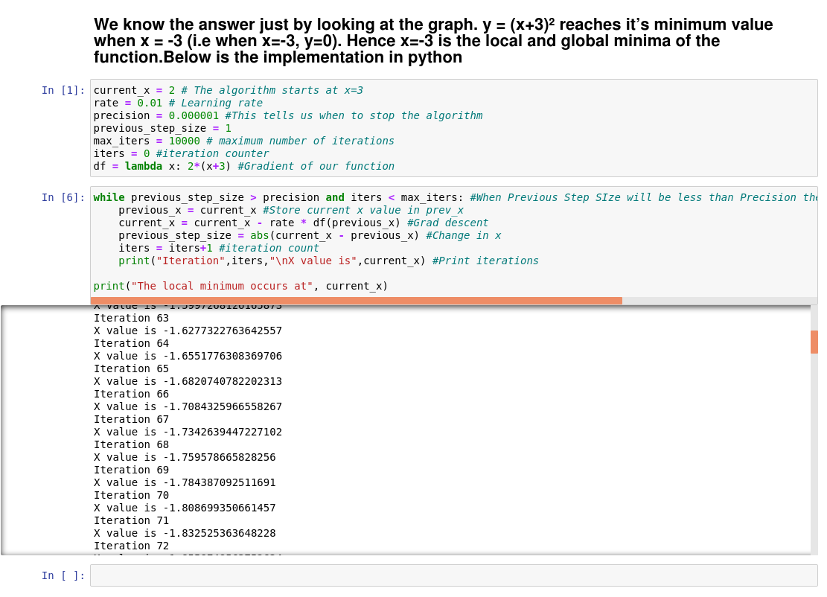

**Assignment No. 4 :-**Implement K-Nearest Neighbors algorithm on diabetes.csv dataset. Compute confusion matrix, accuracy, error rate, precision and recall on the given dataset.Dataset link :<https://www.kaggle.com/datasets/abdallamahgoub/diabetes>.

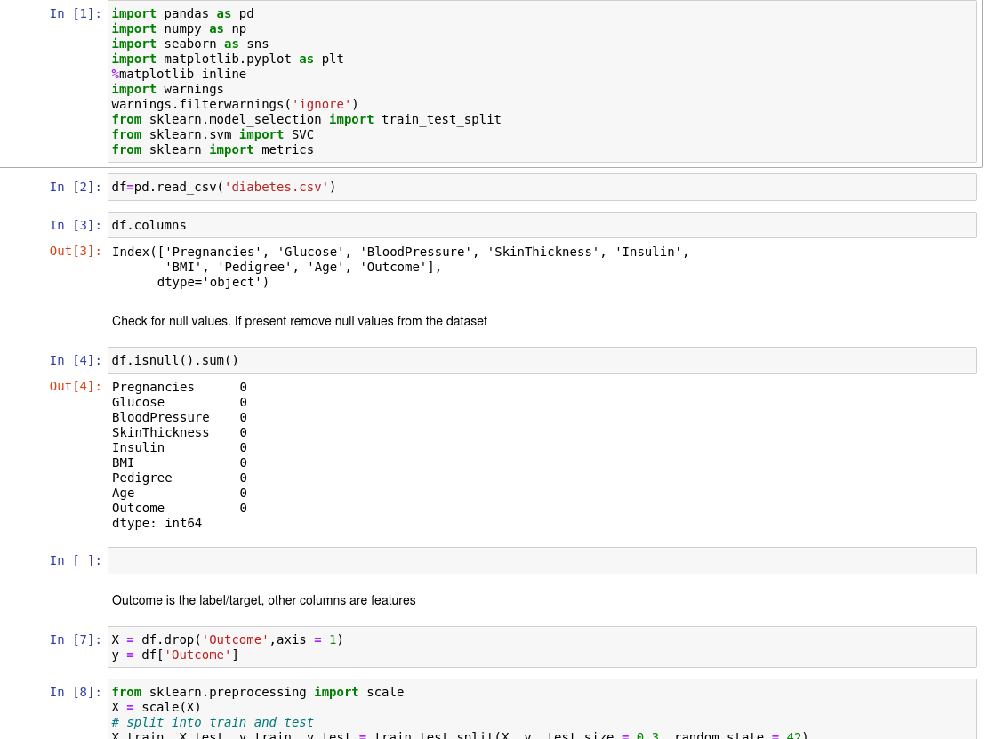

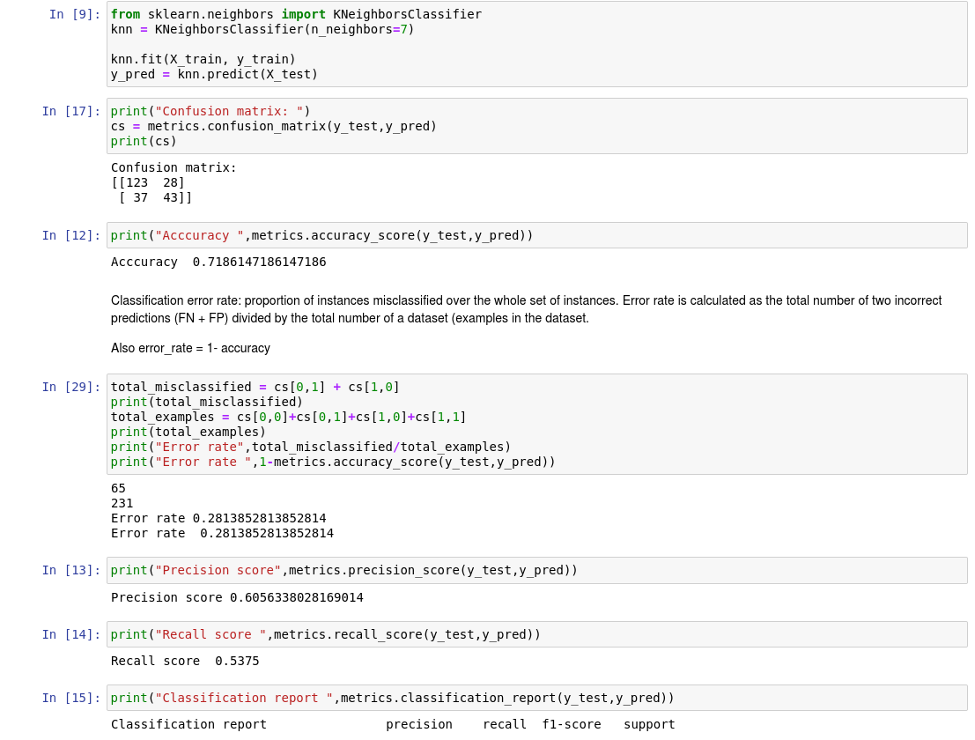

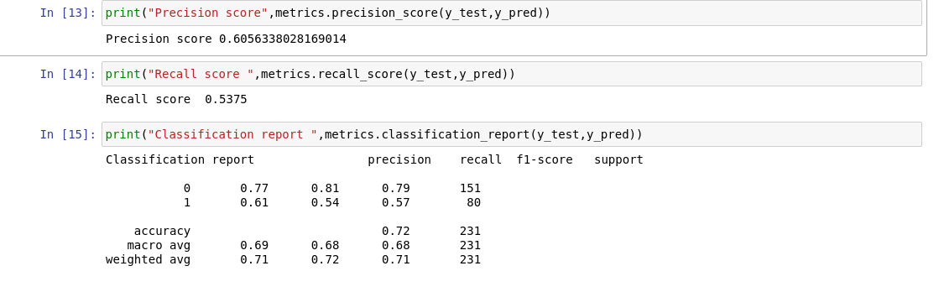

**Assignment No. 5**

Implement K-Means clustering/ hierarchical clustering on sales_data_sample.csv dataset. Determine the number of clusters using the elbow method.Dataset link :<https://www.kaggle.com/datasets/kyanyoga/sample-sales-data>

